SAL INSTITUTE OF TECHNOLOGY AND ENGINEERING RESEARCH
Opp. Science city, Sola-Bhadaj Road, Ahmedabad, Gujarat 380060
Ph: 079 67129000 | Website: www.sal.edu.in

Student's Weekly Report of Internship
Student Name: | Jainil Gupta
Enrollment Number: | 220670132018
Week Duration: | January 22, 2026 - Januray 28, 2026 (Week 4)
Name Of Organization: | Microsoft Elevate Program (via Edunet Foundation & FICE Education)
External Guide Name: | Adarsh Gupta
External Guide Contact: | 0124-4080107
Internal Faculty Guide: | Chintan Rana

Work done in last Week with description:

Week 4 Module: Advanced DAX in Power BI

Description:
Attended comprehensive session on "Advanced DAX" on February 13, 2026. Learned complex DAX functions, iterator functions, and advanced calculation techniques for sophisticated data analysis in Power BI.
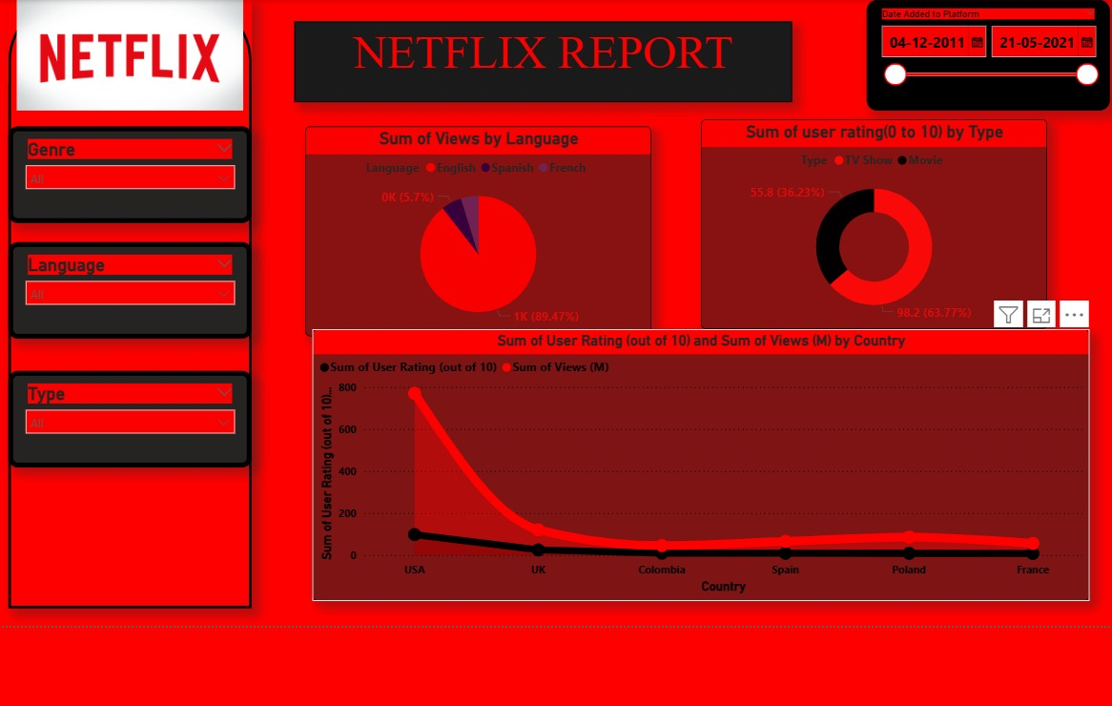

Key Topics Covered:
- Iterator functions: SUMX, AVERAGEX, COUNTX, FILTER
- Time intelligence functions: DATEADD, SAMEPERIODLASTYEAR, PARALLELPERIOD
- Context transition and evaluation context
- ALL, ALLEXCEPT functions for removing filters
- RELATED and RELATEDTABLE for working with relationships
- Performance optimization in DAX queries
- RANKX and other ranking functions

Hands-on Practice:
Created complex measures including Year-over-Year growth calculations, running totals, cumulative sums, and dynamic rankings. Implemented filtering logic using FILTER and ALL functions. Practiced writing efficient DAX formulas for large datasets.

Assignment Completed:
Built sales analysis dashboard with YoY comparison, monthly running total, top 10 products by revenue, and product category performance metrics using advanced DAX measures.

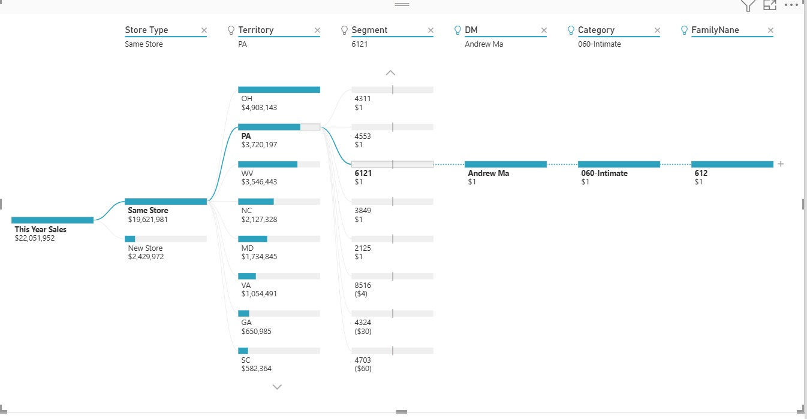

2. Week 4 Module: Power BI Dashboard Development

Description:
Participated in "Power BI Dashboard" session on February 16, 2026. Learned best practices for dashboard design, layout principles, and creating professional, user-friendly analytical dashboards.

Key Topics Covered:
- Dashboard design principles and best practices
- Layout and visual hierarchy for effective communication
- Color theory and accessibility considerations
- KPI cards and key metrics placement
- Creating navigation menus and multi-page reports
- Tooltips and drill-through pages for detailed analysis
- Mobile layout optimization
- Publishing and sharing dashboards in Power BI Service

Dashboard Project:
Created a comprehensive business intelligence dashboard with executive summary page, detailed sales analysis page, and regional performance page. Implemented consistent color scheme, added navigation buttons, and created custom tooltips. Applied mobile view formatting for tablet/phone display.
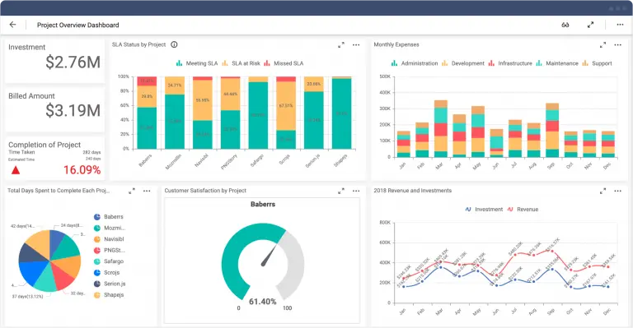

3. Week 4 Module: Introduction to Machine Learning

Description:
Attended foundational session on "Machine Learning" on February 18, 2026. Introduction to ML concepts, types of machine learning, and understanding when to apply ML techniques. This session marked the transition from Business Intelligence to Artificial Intelligence modules.

Key Topics Covered:
- What is Machine Learning? Definition and core concepts
- Types of Machine Learning: Supervised, Unsupervised, Reinforcement
- Difference between AI, ML, and Deep Learning
- Machine Learning workflow: Data → Training → Model → Prediction
- Features, labels, training data, and test data concepts
- Common ML algorithms overview: Linear Regression, Decision Trees, Random Forest
- Real-world ML applications: spam detection, recommendation systems, fraud detection
- Understanding model evaluation metrics: accuracy, precision, recall

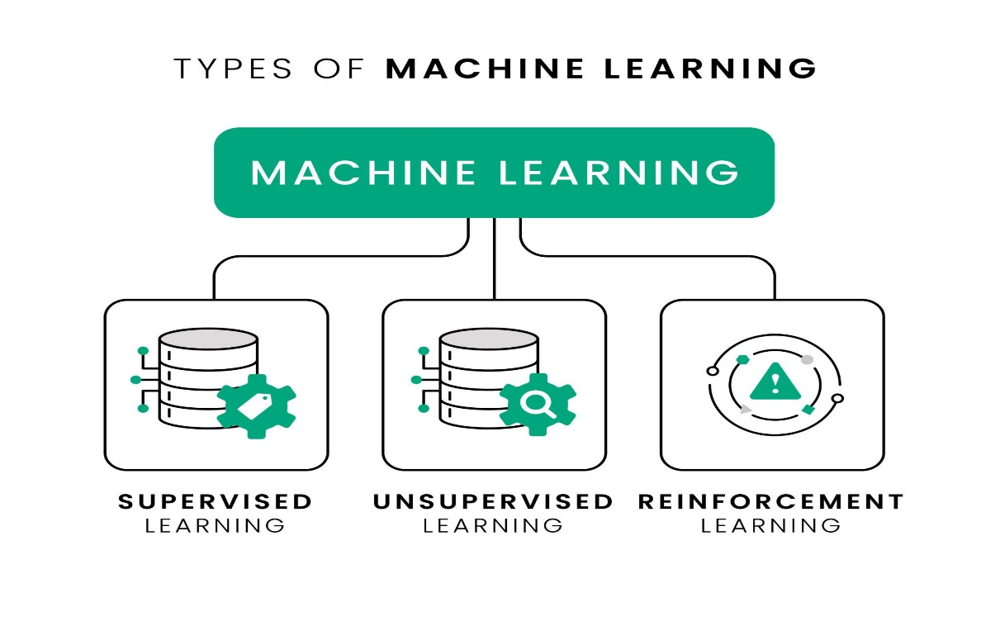

Examples Discussed:
Analyzed practical examples including email spam classification (supervised learning), customer segmentation (unsupervised learning), and Netflix recommendations. Discussed how training data quality affects model performance. Understood the concept of overfitting and underfitting.
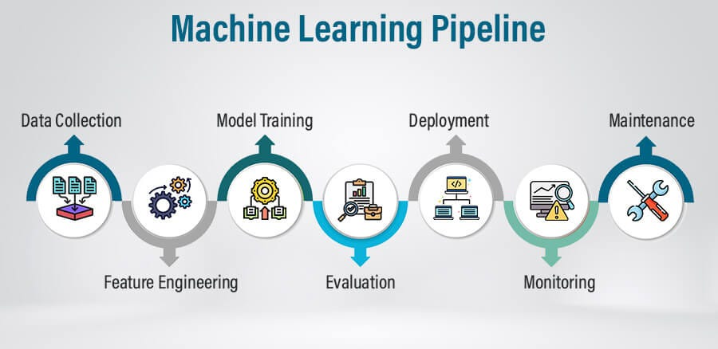

4. Power BI Final Assignment Completion

Description:
Completed and submitted comprehensive Power BI assignment covering all topics learned from Week 3-4 including data modeling, DAX, visualizations, and dashboard design.

Assignment Components:
- Connected to sample dataset (Superstore or similar business data)
- Created data model with proper relationships between tables
- Implemented 10+ DAX measures including YTD, MTD, YoY growth
- Built 3-page dashboard: Overview, Sales Analysis, Regional Performance
- Added interactivity with slicers, filters, and drill-through
- Applied professional design with consistent theme and layout
- Submitted .pbix file to MS Elevate portal

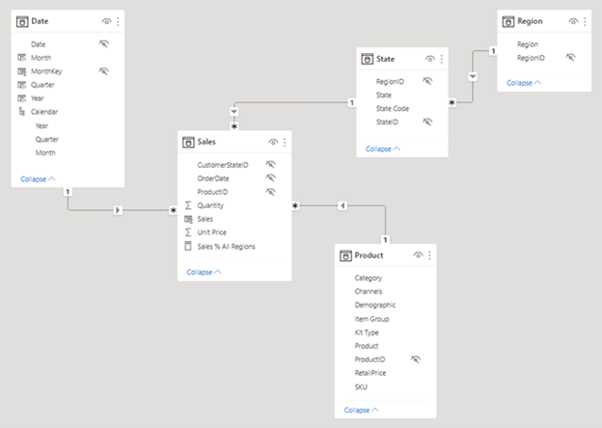

5. Peer Learning Session and Q&A

Description:
Participated in peer discussion sessions and doubt-clearing sessions. Engaged with fellow interns to share knowledge, discuss Power BI challenges, and prepare for upcoming Machine Learning modules.

Activities:
- Helped peers debug DAX formula errors in discussion forum
- Shared dashboard design tips and best practices learned
- Discussed upcoming ML topics and prepared questions
- Reviewed sample ML problems to build foundational understanding

6. GTU Project - Minor Documentation Update

Description:
Updated project documentation and maintained organized folder structure. Primary focus this week was on completing Microsoft Elevate modules and assignments.

Minor Updates:
- Updated project README with current progress status
- Organized downloaded dataset files in proper directory structure
- Reviewed YOLOv8 documentation for Week 5 implementation

Note:
Detailed project work will resume in Week 5 after completing supervised learning module, which is essential for understanding object detection algorithms.

Plans for next week:

1. Complete Week 5 Microsoft Elevate Modules
- Attend "Supervised Learning" session (Feb 20)
- Participate in "Unsupervised Learning" session (Feb 23)
- Learn about "Reinforcement Learning" (Feb 25)
- Practice ML algorithms using scikit-learn

2. Machine Learning Hands-on Practice
- Complete supervised learning exercises (Linear Regression, Classification)
- Practice model training and evaluation
- Learn train-test split and cross-validation
- Work with sample datasets from scikit-learn

3. Prepare for Deep Learning Module
- Review neural network fundamentals
- Install TensorFlow and Keras libraries
- Study basic concepts: layers, activation functions, backpropagation
- Prepare questions for Week 6 Deep Learning sessions

4. Continue Learning GitHub and Version Control
- Complete GitHub basics tutorial
- Learn git commands: commit, push, pull, branch
- Practice creating and managing repository
- Prepare project repository structure for Week 6

Total Working Hours: 30 hours
Signature of Student: _____________________
The above entries are correct, and the grading of work done by Trainee is:
Excellent | Very Good | Good | Fair | Below Average | Poor
☐ | ☐ | ☐ | ☐ | ☐ | ☐

Signature of External Guide with Company Seal:
Date: 28/01/2026
Signature of Internal Guide: _____________________
Date: 28/01/2026

